B | I | N | G | O
 | 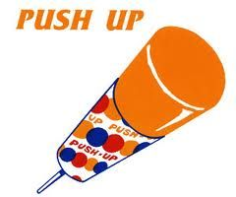 |  | 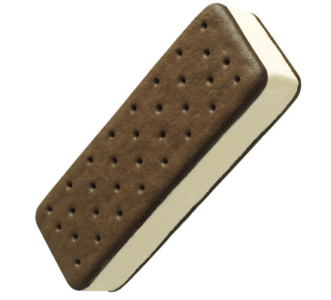
. | 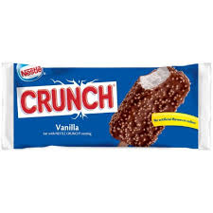 | 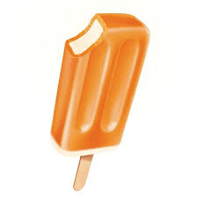 |  | 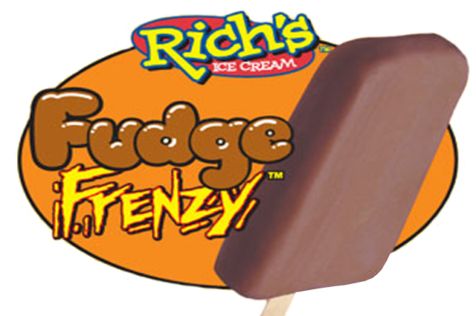
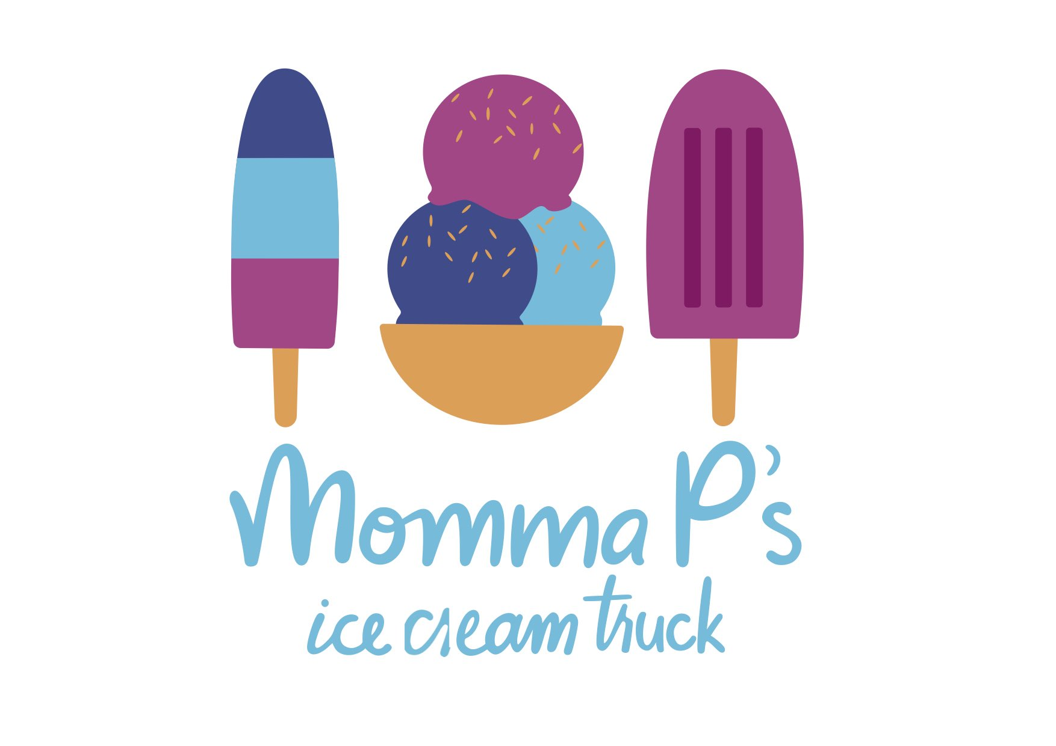

FREE SPACE
Post a pic w/ you & your classic ice cream treat…tag Momma P.

*Facebook & Instagram
Rules:
1. Let’s not overcomplicate this- this is not the Hunger Games
2. Print out
3. You will receive a stamp for the item you order. Must have BINGO present to get stamp.
4. No limit to how many Faces you can buy per visit, so no limit to how many stamps you can get per visit.
5. Popsicle availability depends on my suppliers…so let’s be flexible.
6. FREE ice cream for a COMPLETELY filled out card!

